Objective
This week's focus was to connect the M5Stack Core2 to AWS IoT Core using MQTT and SSL, and to merge two separate code bases into a unified, functional script. These are critical steps for enabling real-time data publishing from our sensors and preparing the data for further analysis and cleaning.

Challenges Encountered
- AWS IoT MQTT Connection Using SSL
  - Goal:
Establish a secure SSL connection between the M5Stack Core2 and AWS IoT, read temperature and humidity data, and publish this data via MQTT.
  - Issue:
During the setup of the SSL connection, the program encountered a "Value Error: invalid key" when trying to connect to AWS IoT over MQTT using SSL.
  - Root Cause:
MicroPython’s umqtt module does not support SSL key and certificate handling the same way as standard Python. Our initial approach tried to use more advanced Python techniques that aren’t compatible with MicroPython’s simplified handling of SSL.
- UIFlow Code Block to MicroPython Transition
  - Goal:
Use UIFlow’s block-based programming environment to configure MQTT and AWS IoT connections, and then translate the block code into MicroPython to customize the logic further.
  - Issue:
When transitioning from the UIFlow-generated blocks to MicroPython, we faced multiple syntax errors, especially in the way SSL certificates were being handled.
  - Root Cause:
UIFlow’s block code generation doesn’t always translate well into MicroPython when dealing with more complex features like certificate management. The file paths and structures weren’t adapted correctly for MicroPython’s requirements, causing errors.
- Incorrect SSL Certificate File Paths
  - Goal:
Load SSL certificates and keys correctly from the M5Stack Core2’s file system to establish a secure connection with AWS IoT Core.
  - Issue:
The program threw FileNotFoundError and "invalid key" errors when trying to access the SSL certificates from paths such as /flash/res/priv.key.
  - Root Cause:
The certificate files weren’t properly transferred to the M5Stack’s internal storage. The /flash directory, which was expected to contain the files, wasn’t mapped to external storage (like OneDrive) correctly, so the device couldn’t find the required SSL files.
- SSL Certificate and Socket Wrapping with ussl.wrap_socket
  - Goal:
Wrap the network socket in SSL to secure the MQTT communication.
  - Issue:
We encountered syntax errors when trying to wrap the socket using ussl.wrap_socket, particularly due to the improper handling of the certificates and key files.
  - Root Cause:
MicroPython’s ussl module has limited support for certificate and key files compared to regular Python. We were trying to pass SSL certificates in a way that wasn’t compatible with MicroPython’s simpler SSL implementation.
- Connection to AWS IoT Core Using umqtt.simple
  - Goal:
Establish a secure connection to AWS IoT Core using the umqtt.simple module, and publish the temperature and humidity data collected from the sensors.
  - Issue:
The connection attempts to AWS IoT Core failed due to issues with SSL certificates and incorrect syntax in the MQTT setup.
  - Root Cause:
The umqtt.simple module in MicroPython has limitations when handling SSL connections, and our setup didn’t account for these constraints. Additionally, incorrect file paths for the SSL certificates prevented the connection from being successfully established.
- Reading Certificates from Local Storage
  - Goal:
Properly load SSL certificates from the M5Stack Core2’s local storage to support the secure connection.
  - Issue:
There were errors in accessing the certificate files due to the program pointing to incorrect file paths.
  - Root Cause:
The file paths used in the code didn’t align with the M5Stack Core2’s internal storage structure. As a result, the program couldn’t locate the required SSL files, which caused the SSL connection to fail.
- Continuous Connection Loop Development
  - Goal:
Create a stable connection loop that continuously reads sensor data and publishes it to AWS IoT Core in real-time.
  - Issue:
Syntax errors occurred during the initialization of the MQTT client and while wrapping the socket with SSL in a continuous loop.
  - Root Cause:
Our approach mixed unsupported parameters and functions when setting up SSL and MQTT, which led to persistent errors in the connection loop.

Successful AWS codes in Micro Python
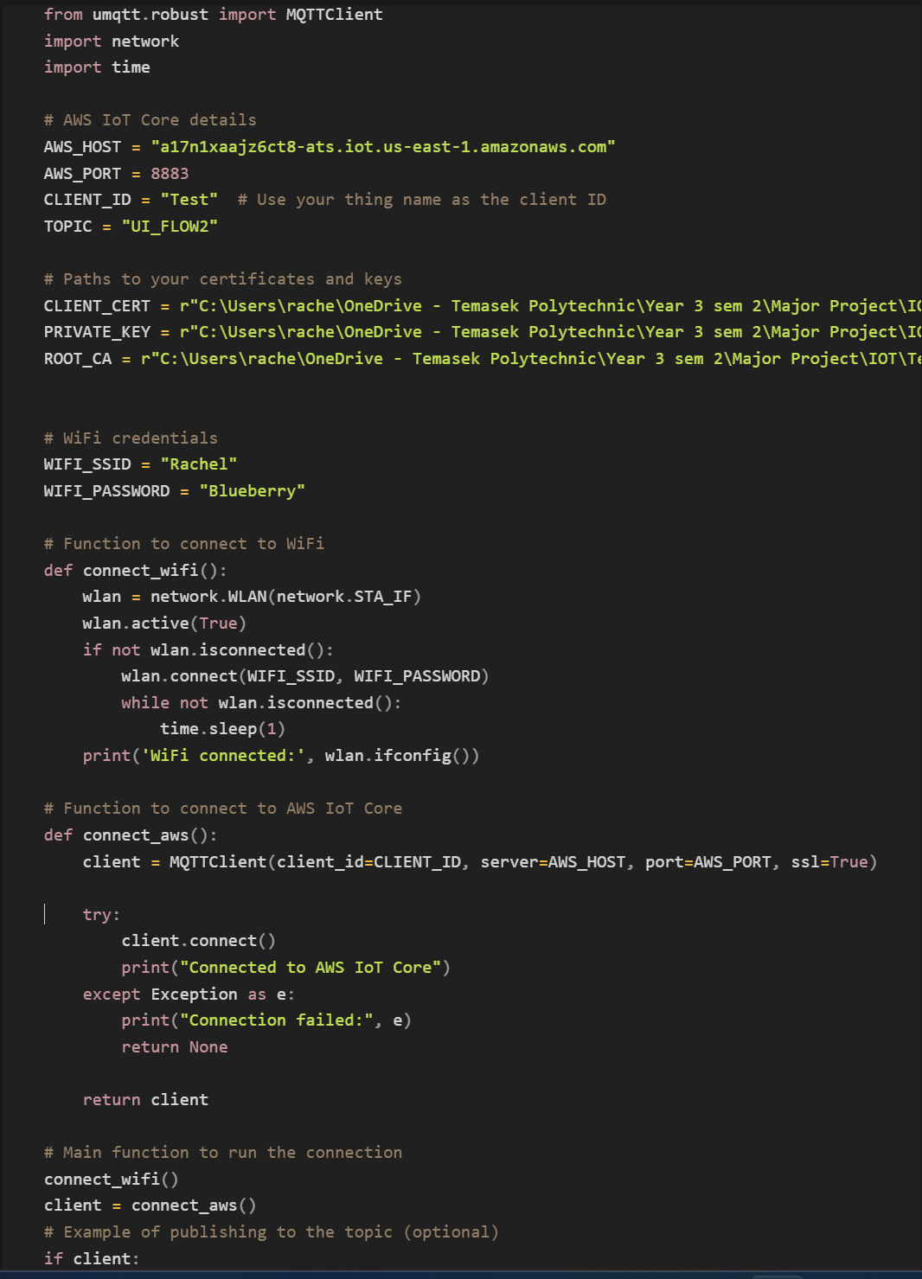

What Worked or Partially Worked
- Wi-Fi Connection
  - Goal:
Connect the M5Stack Core2 to the local Wi-Fi network.
  - Success:
The M5Stack successfully connected to the Wi-Fi using the provided SSID and password.
  - Why It Worked:
The network.WLAN module in MicroPython is reliable and the connection logic was implemented correctly. A loop was set up to wait until the Wi-Fi connection was established before moving on to other tasks.
- Basic LCD Display
  - Goal:
Display temperature and humidity data on the M5Stack Core2’s LCD screen.
  - Success:
The screen was initialized and updated with sensor data as expected.
  - Why It Worked:
The M5Stack libraries, such as m5stack and m5stack_ui, were used properly to control the LCD. The screen was configured correctly to display messages and sensor readings.
- Reading Sensor Data (Analog Sensors)
  - Goal:
Read temperature and humidity data from the analog sensors connected to the M5Stack Core2.
  - Success:
The sensors provided valid readings, which were processed into meaningful temperature and humidity values.
  - Why It Worked:
The ADC (Analog-to-Digital Converter) was correctly initialized with appropriate settings. Scaling functions were applied to convert the raw data into usable values.
- File Loading Logic for SSL Certificates
  - Goal:
Read SSL certificates and keys from the file system to set up secure MQTT communication.
  - Partial Success:
The function for loading certificates worked, assuming the file paths were correct.
  - Why It Worked:
The open() function for reading files was properly implemented, with adequate error handling for missing files.
- Basic MQTT without SSL
  - Goal:
Use the umqtt.simple module to publish data to an MQTT broker without SSL.
  - Partial Success:
Although the AWS IoT connection using SSL wasn’t successful, basic MQTT publishing worked on simpler servers that didn’t require SSL.
  - Why It Worked:
The MQTT client setup, subscribing to topics, and publishing data were handled correctly, without the added complexity of SSL.

Lessons Learned
- Simplified SSL Handling:
Micro Python’s ussl module requires a more simplified approach to SSL, where certificates cannot be handled the same way as in standard Python. Future attempts should avoid passing file paths directly and explore alternatives for secure communication.
- Micro Python’s Limitations with AWS IoT:
The umqtt.simple module in Micro Python has certain limitations when it comes to SSL connections, particularly for complex setups like AWS IoT Core. We need to adapt our approach to work within these constraints or consider alternatives.
- File Path Management:
The handling of certificate and key file paths is crucial. Certificates need to be correctly transferred and stored on the M5Stack’s internal flash memory to ensure they can be accessed without errors.
- Wi-Fi Stability:
The Wi-Fi connection remained stable throughout testing, but more work is needed on the SSL and MQTT side to achieve full functionality with AWS IoT.

Next Steps
- Refine SSL and MQTT Setup:
Simplify the SSL implementation to work within Micro Python’s limitations and ensure the MQTT connection is stable. We’ll also explore whether an alternative library could offer better compatibility.
- File Path Correction:
We’ll ensure the SSL certificates are correctly stored in the M5Stack’s internal storage and refine the file paths in the code to avoid future access errors.
- Merge Codebases:
The two separate codebases (Wi-Fi/MQTT setup and sensor reading) will be integrated into one functional script. This will streamline the process and make future testing smoother.
- Test Data Publication:
Once the SSL and MQTT issues are resolved, the next step is to connect to AWS IoT Core and successfully publish sensor data in real time. This is critical before we can begin data cleaning and further processing.

Second attempt using Blocky
Using blocky we tried a second round of integration comparing which was optimal for aws integration.
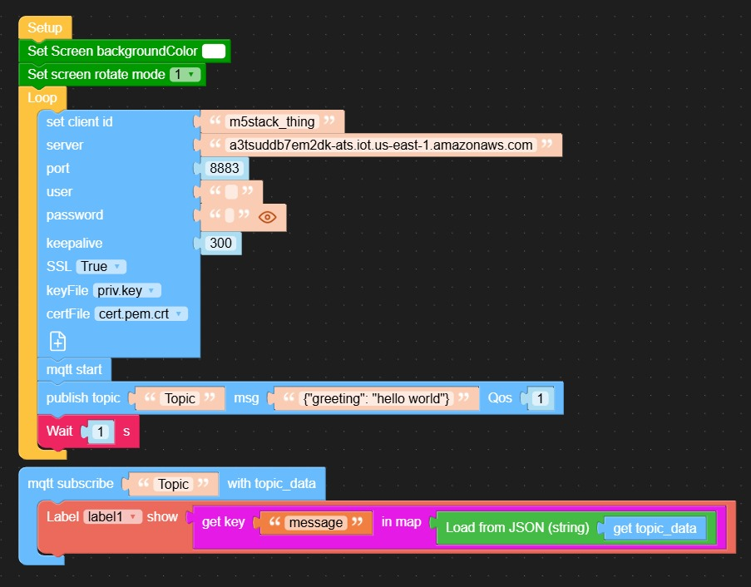

Visual Screen
- Set Screen Background Color and Set Screen Rotate Mode:
  - The blocks are set up for display onto the M5 stack Core 2 device allowing the colour to be set to white and allowing is so that everything is upright

Connection Setup
- MQTT Connection Settings:
  - Client ID: a unique name for your device (in this case, it’s "m5stack_thing"), which AWS IoT uses to recognize the device.
  - Server: TheURL of the AWS IoT server. This is the“address” your device connects to for sending and receiving data.
  - Port: The port number is 8883, which is specifically for secure MQTT connections.
  - SSL: SSL (Secure Sockets Layer) is enabled, meaning your data is encrypted during transmission for added security.
  - Key File and Cert File: These files (your private key and certificate) authenticate your device with AWS IoT, confirming that it’s allowed to connect.

- MQTT Start:
  - This block starts the MQTT connection allowing the device to communicate with AWS IoT.

Publishing Data
- Publish Topic:
  - This block sends data to AWS IoT. It:
    - Topic: Think of a topic as a “channel” that your device can send or listen to messages on. You’re choosing to publish on a topic called "Topic".
    - Message: The message being sent here is {"greeting": "hello world"}, which is in JSON format.
    - QoS (Quality of Service): Setting QoS to 1 ensures that AWS IoT will receive the message.

Receiving Data
- MQTT Subscribe:
  - This block tells the device to “listen” for any messages sent to the "Topic" channel.
- Label Display:
  - When a message is received, this block extracts specific information and displays it:
    - Load from JSON: This block reads the incoming message (stored as topic_data) in JSON format.
    - Get Key: It looks for a specific key within the JSON data, here "message".
    - Show on Label: The value of "message" is then displayed on the device’s screen in label1.
AWS IOT
- Open AWS learner Lab, open up AWS IOT and go to things this should be located under all devices
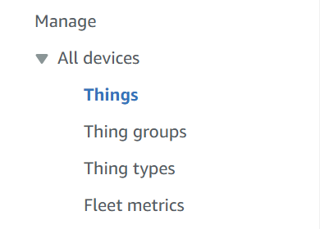

- After locating things to connect to the M5 stack we need to procced to make a new thing to put as our “topic”
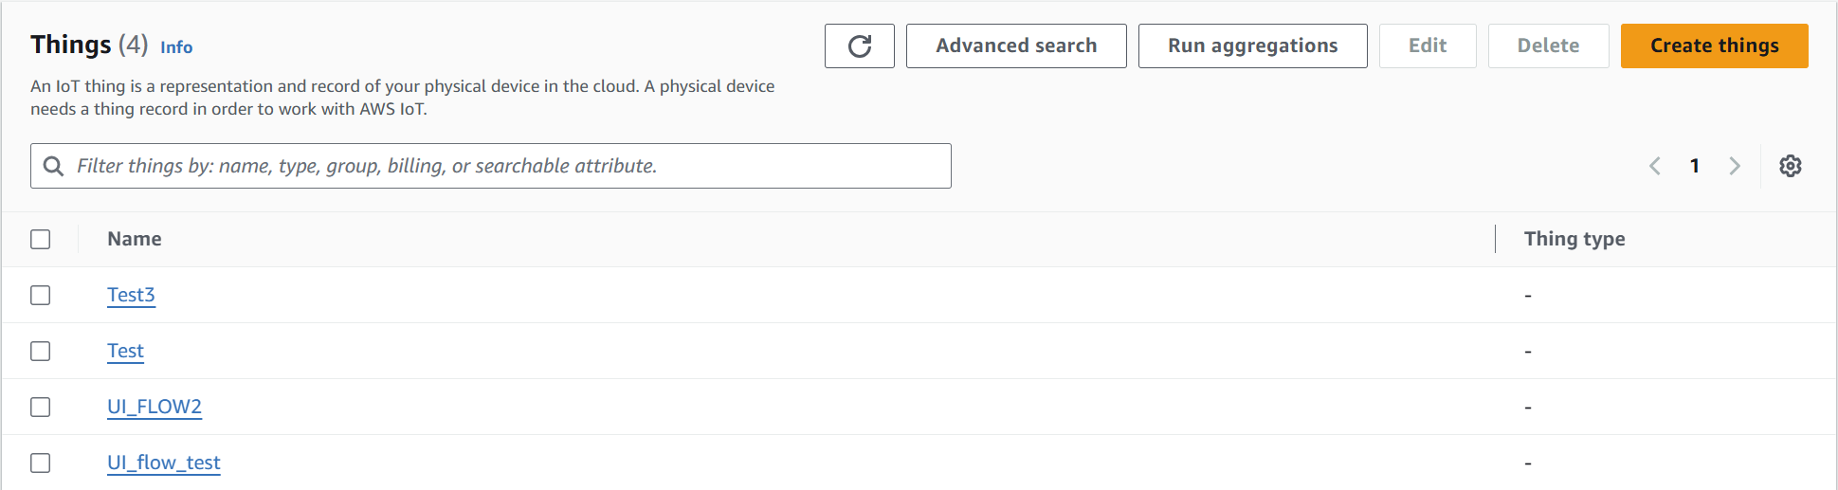
- Select “create thing” and procced forward

- In this case we will be using “create single thing” for our project then click “next”
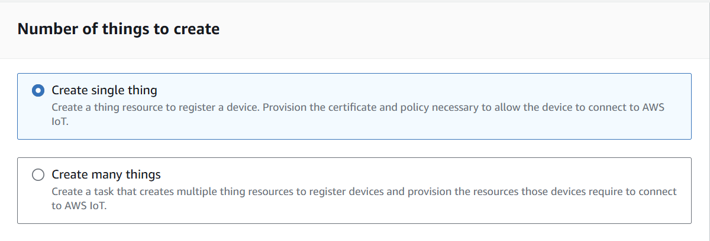

- Procceding forward we will be naming out thing, be mindful to keep it simple for easier configuring and less spelling mistakes in the long run. Enter in “thing name” to name the object in my case I used “Test”. We will leave the rest of the configurtations as default. Then click “next”. 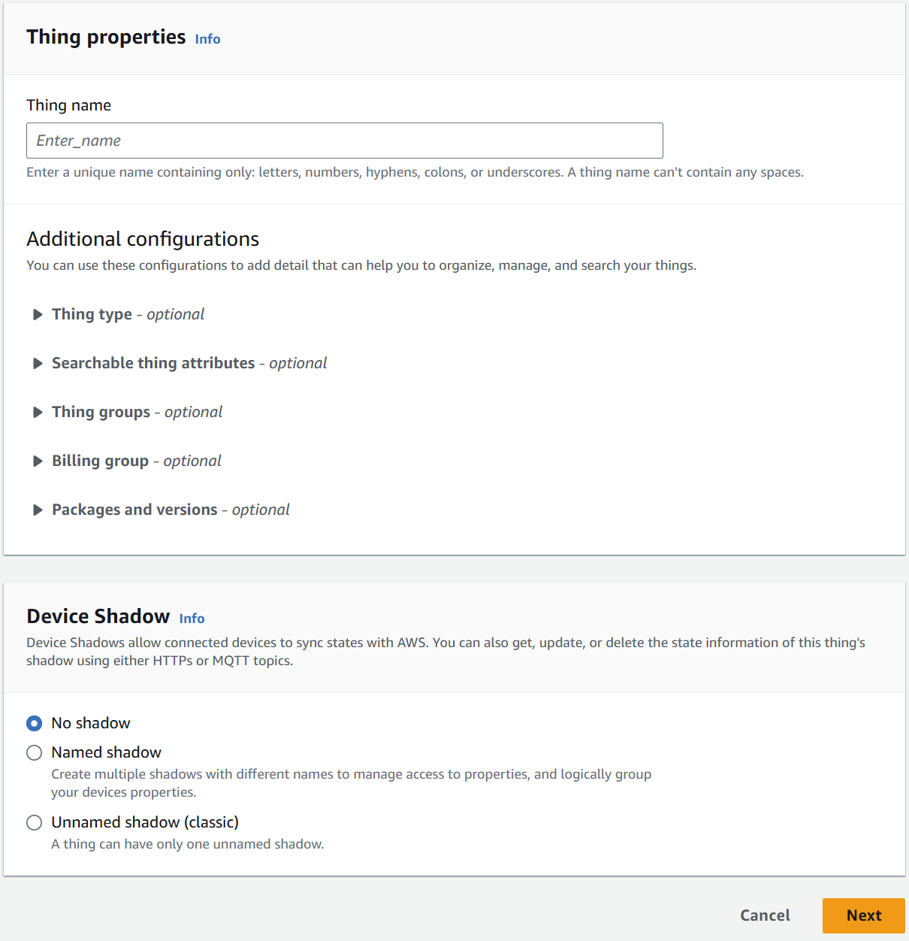

- Same as earlier we will be leaving this one in its default settings as we don’t have any predownloaded certificates that we will need to use or regenerate. Once selected we will click “next”. 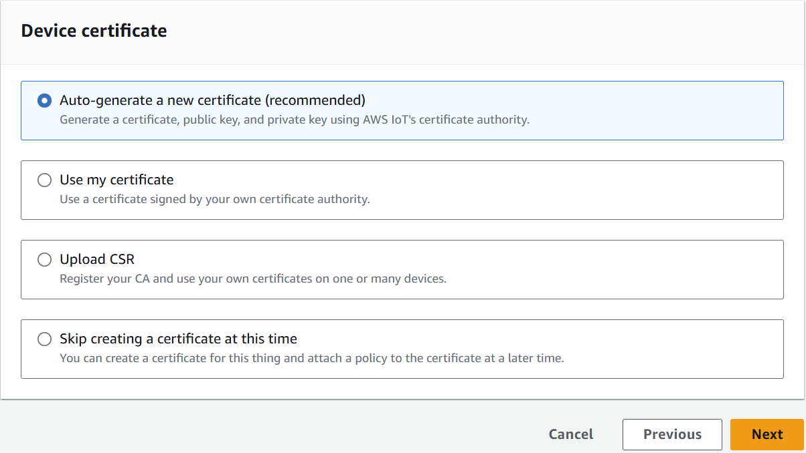

- Going on we will be attaching a policy to the thing this will allow our thing to have the permission to retrieve and send messages as well as who has access to the files.

- This is done by clicking into create policy in this cause I used ( insert json code ). After which coming back to the page as shown below, I will choose the policy I made called “test” then press “create thing” 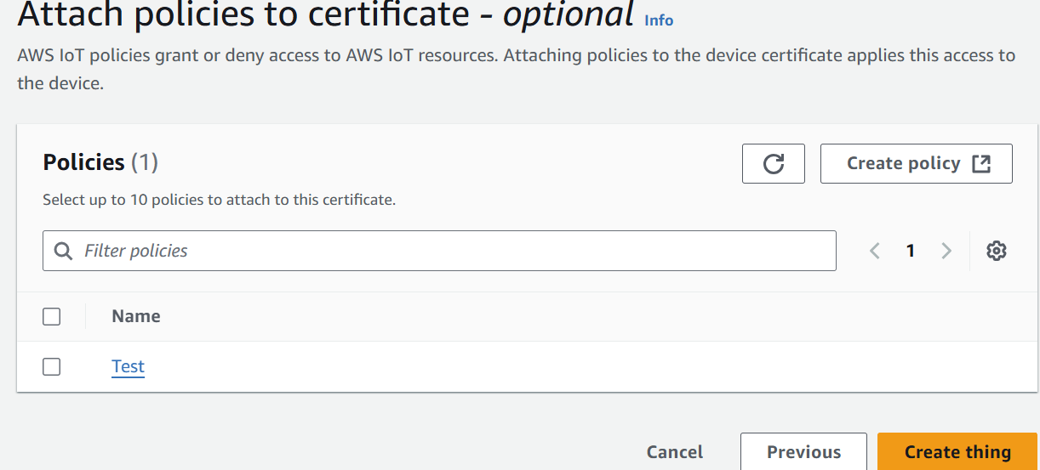

- A pop up will coming asking to download certificates, download all the certificates and store it into a file in your personal device this is what we will be using to connect the AWS and IOT. The main files we will be using the is the private key and the device certificate. For this configuration we will also be using the root CA certificates. 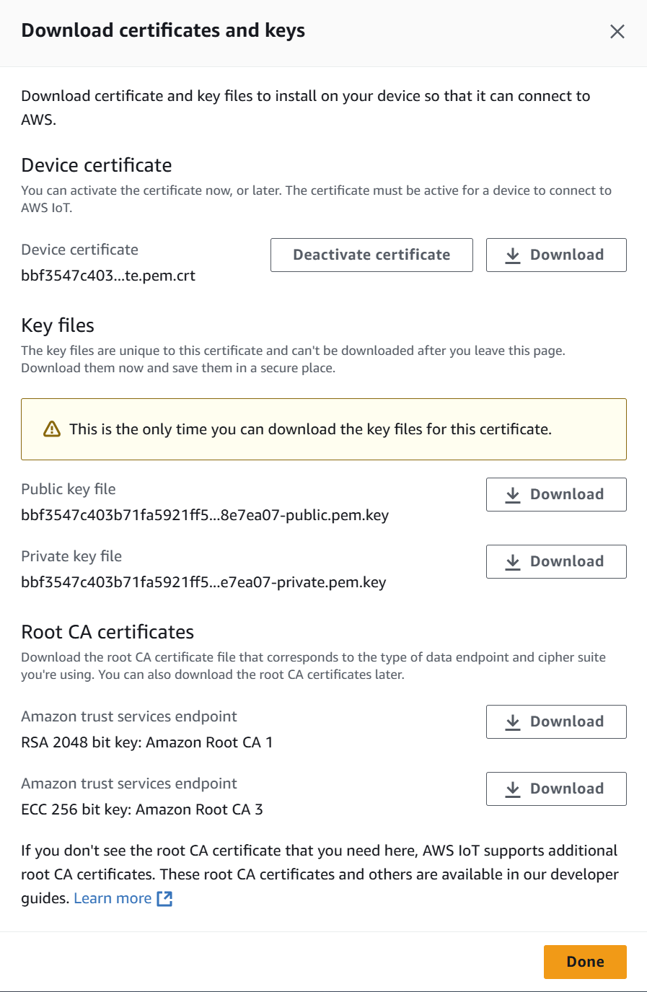

- Going back to our Blocky / Mircopython we will add in the files into the code/ blocky. We will also name our “client_id” based on our thing name. While our topic name can be anything under the moon. In this scenario it is “UI_FLOW2”. In the end It should look something like the image below. 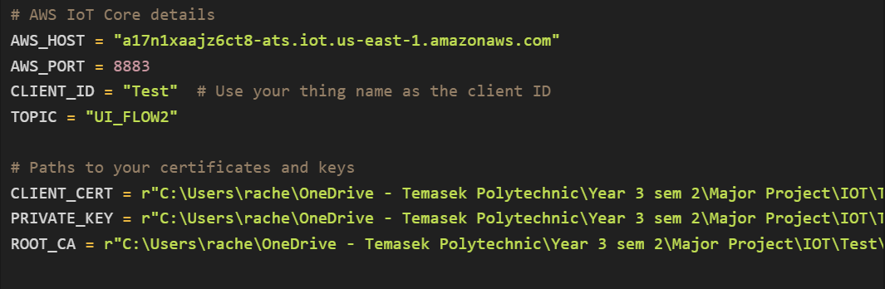

- To test the connection between the aws and the iot we will be using the “MQTT test client”. This can be found in the left nav bar under “test”. Upon coming to this page we will be going forward with subscribing to the topic we allocated in the blocky/micro python. In this case we will be using “UI_FLOW2” then click “subscribe” 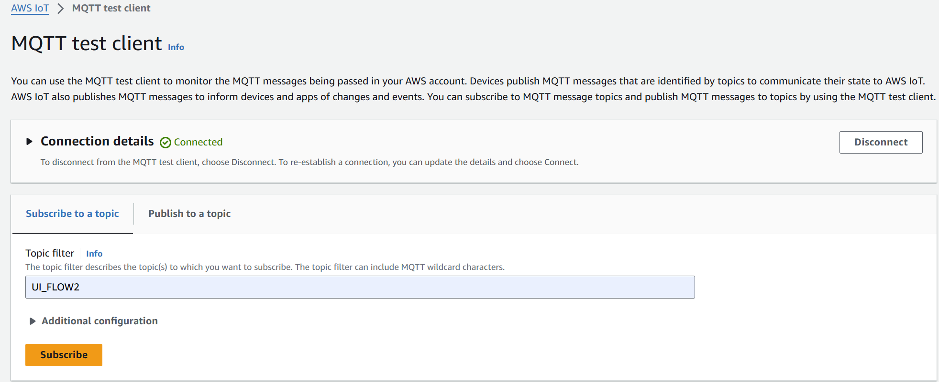

- Click on “publish to a topic” to test the connection, this will allow us to see the timestamp and the connection of the AWS and IOT. This will also allow us to send messages to the IOT in the “topic name” put in our current topic name “UI_FLOW2” to send messages back into the IOT. 